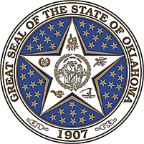

Commission for Educational Quality and Accountability (CEQA)

REGULAR MEETING AGENDA

Wednesday, March 11, 2015, 2:00 P.M.

Room 419-A, State Capitol Building
Oklahoma City, OK 73105

The Commission for Educational Quality & Accountability may take action on any agenda item.

Welcome: Dr. Sherry Labyer, OEQA Executive Director

Call to Order: Secretary of Education Natalie Shirley, Chair

Introduction of Commission Members and Roll Call: Ms. Angie Bookout

Approval of Minutes: Regular February 18, 2015 OEQA Commission Meeting

- Discussion of setting performance benchmarks for the Oklahoma Educational Indicator’s Profiles reports

- Quality and Accountability Program Reviews/Updates – OEQA Staff

- Discussion of Financial Disclosure Statement/Oklahoma Ethics Commission – Dr. Sherry Labyer

- New Business

- Announcements and Information Items

- Adjournment

